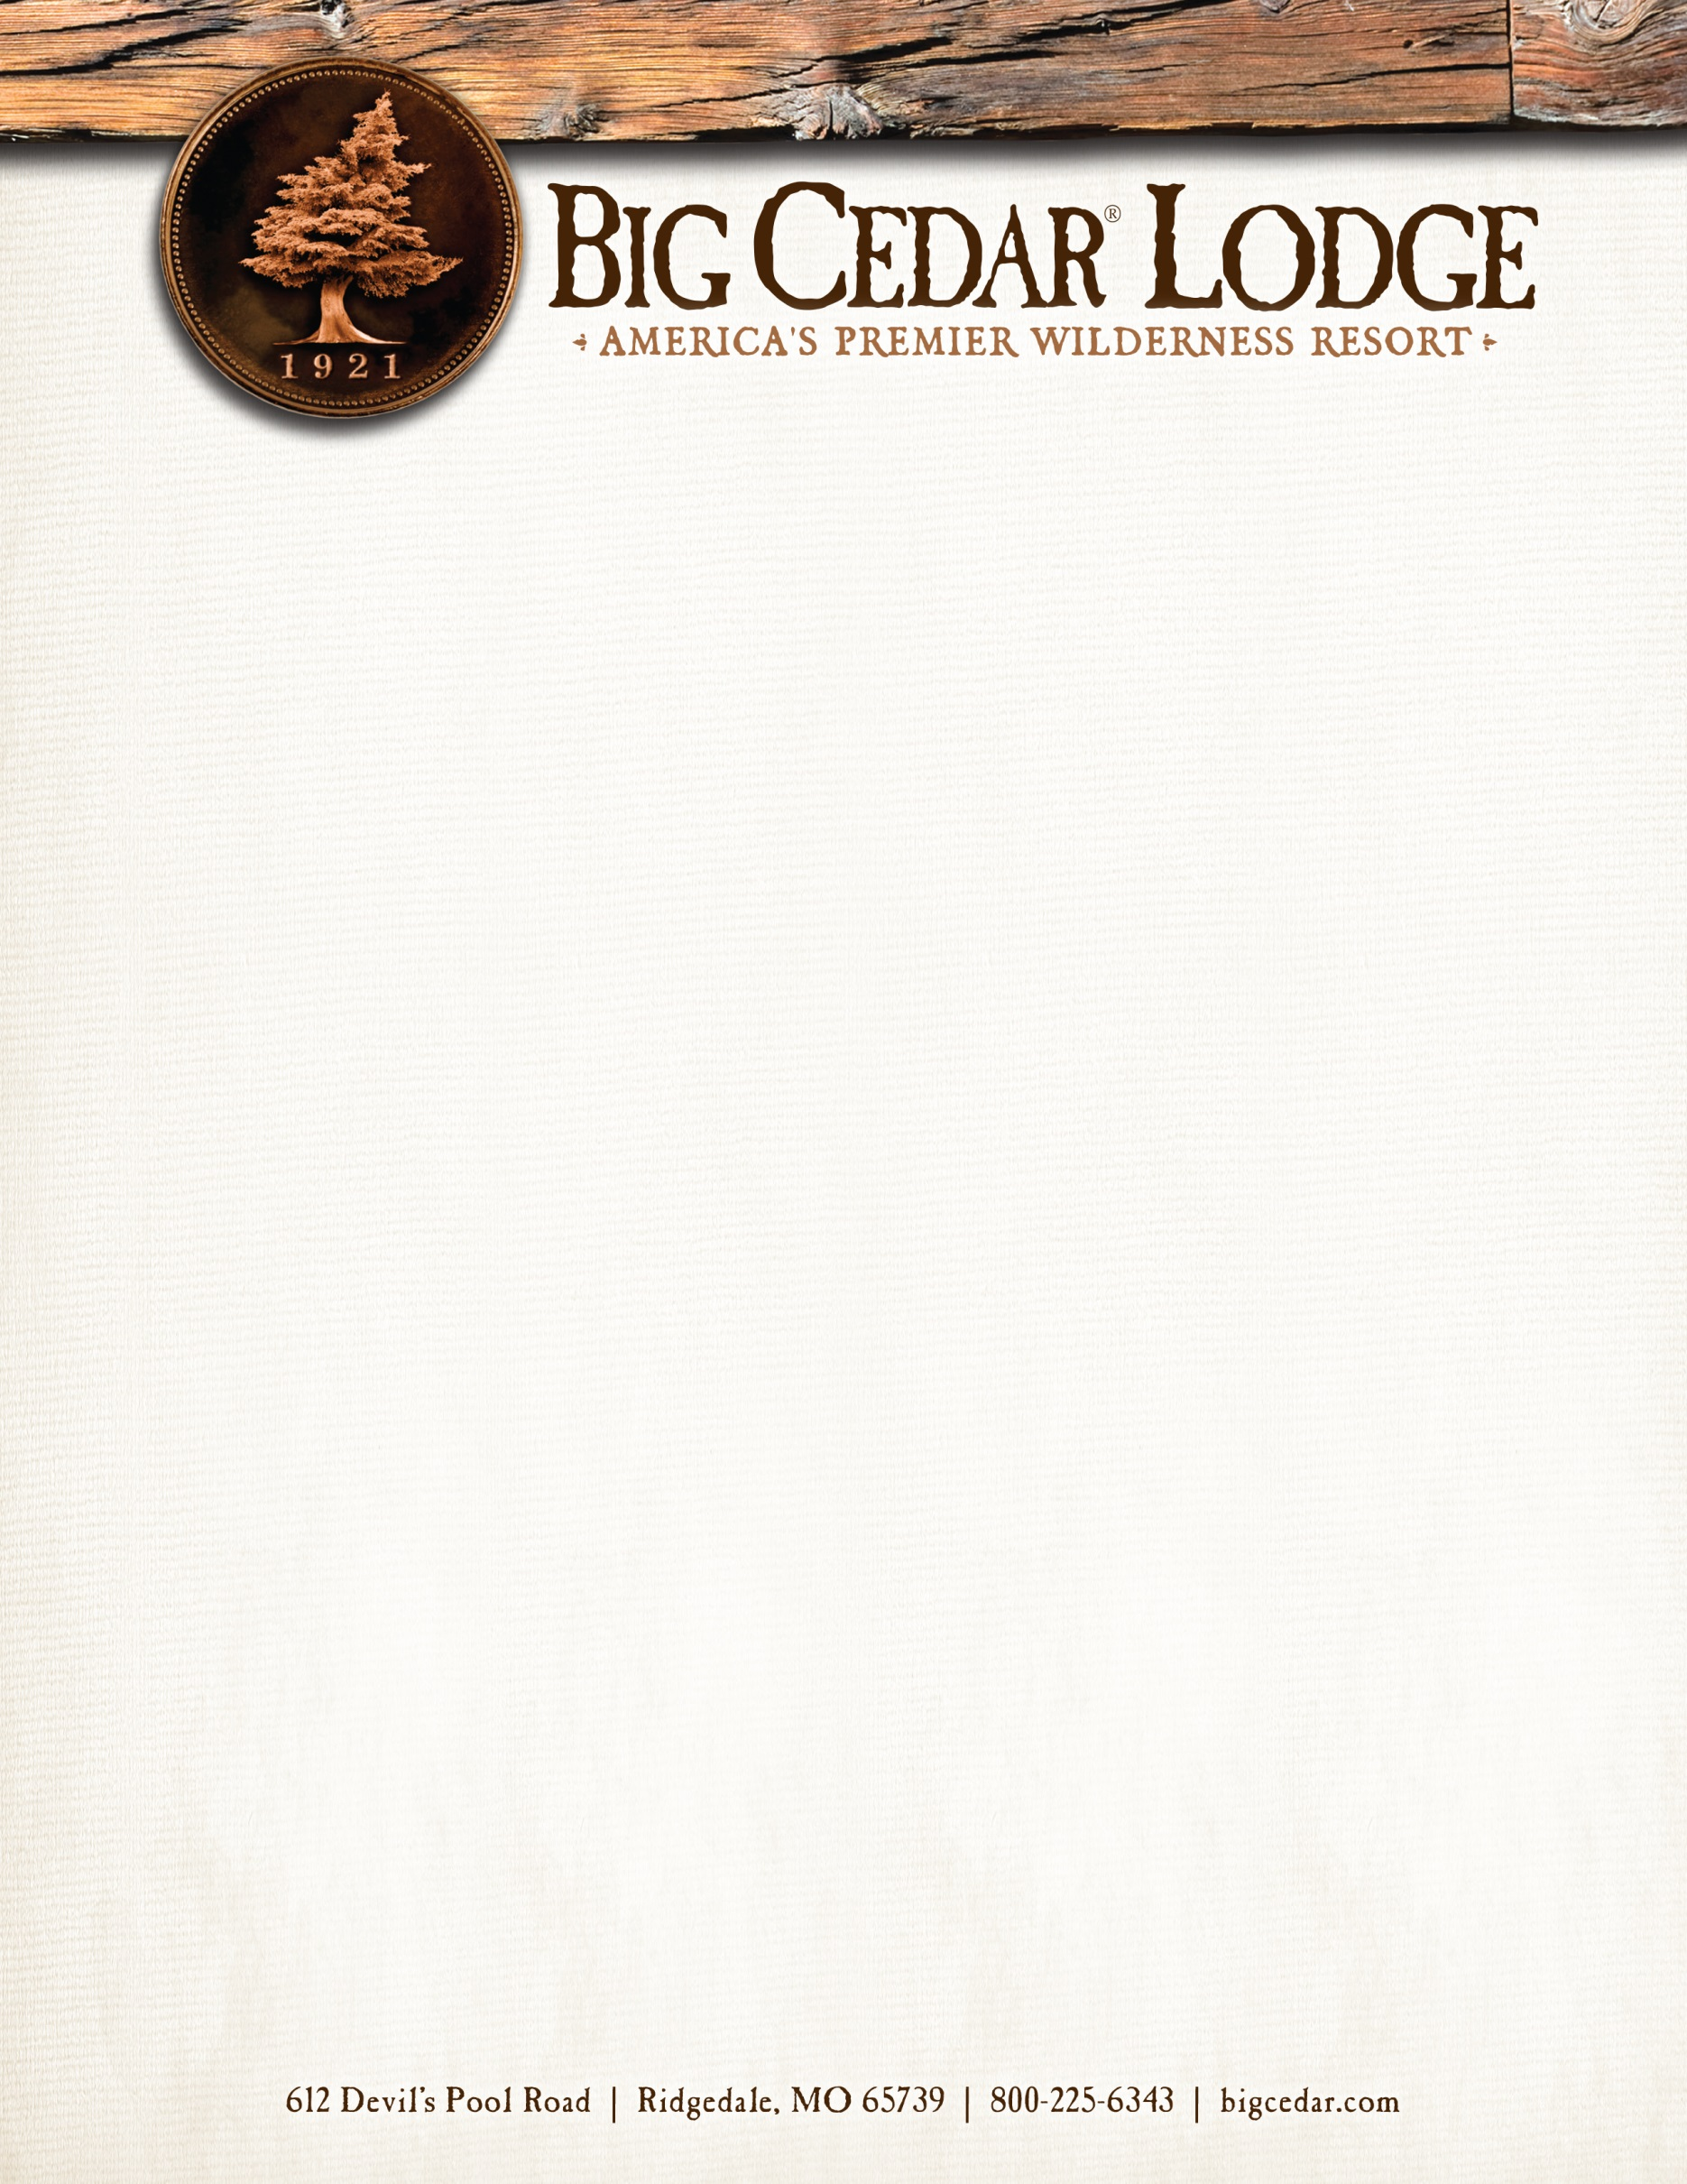

Big Cedar Lodge welcomes: The Tick Chicks
Group #6292VB
Group Arrival Date: Friday, October 7, 2022
Group Departure Date: Sunday, October 9, 2022
Reservation Due Date: Tuesday, August 23, 2022

We are so excited for you to stay with us! Big Cedar Lodge is the wilderness resort of choice for guests who expect genuine hospitality, outstanding service, and a relaxing experience surrounded by nature and rustic elegance. In order to provide the best possible service I have listed the reservation options below.

Book Online at bigcedar.com
- Select your arrival and departure dates
- Select number of adults and children
- Click ‘Add Special Code’
- Below ‘Group’ enter 6292VB
- Click ‘Apply’
- Click ‘Search’

You will find the room types available at a group rate during the dates of the event in vibrant color. Please call
to check availability and pricing of uncontracted dates and room types using the instructions below:

Phone Reservations:
- Call Toll Free at (855) 270-5603
- Select 1 for New Reservations
- Select 2 for Group Reservations
- Provide the reservationist with your group number: 6292VB

Thank you for choosing Big Cedar Lodge, we look forward to your arrival!

